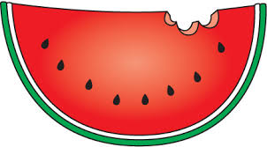
Watermelon Royalty
Application 2016

The Applicant must be able to make the following dates and times: May 31st from 11:00-1:00 PM (pageant), and June 3rd 12:00-2:00 PM (Watermelon Drop)
If participating as a group, there is a max of 2 people. The Application is DUE MAY 29th by 5 PM to revrpb@ucsd.edu

Applicants will be contacted prior to the pageant to discuss their talent. Applicants may bring whatever items they may need to perform their talent.
If you have any questions, please email Revelle Programming Board at revrpb@ucsd.edu.
Name__________________________
Year___________________________
Major__________________________
Phone Number__________________
UCSD Email_____________________

Please tell us about your talent:

How has your relationship with watermelons positively influenced your life?

What is your criteria for a perfect watermelon?

How do you feel about tensions between cantaloupe and watermelon, and how could this conflict be resolved?

