Appointments Packet
2014-2015

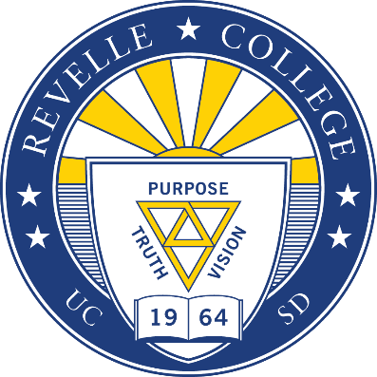
Dear Applicant,

Thank you for your interest in joining the Revelle College Council (RCC). RCC is the student governing body for Revelle College and oversees many of the events that Revelle College enjoys, while also being responsible for financial, legislative, and campus initiatives. Members of RCC help publicize, fund, and plan Revelle College events, while working closely with other college councils, the Associated Students, and college administrators to foster a cohesive Revelle community. RCC is composed of a dynamic group of proactive individuals who are willing to work together on a daily basis to serve the students of Revelle and UC San Diego.

Being a part of RCC will allow you to gain leadership skills and knowledge, while building lasting friendships. The level of satisfaction you will retain from your work in RCC directly relates to your goals with the council and your future careers, no matter what they may be.

During the AS Elections, candidates for RCC may run for one of many positions as stated below:

- President
- Vice President
- Director of Finance
- Director of Visibility
- Director of Administration
- Director of Special Events
- Director of Student Services
- Revelle Organizations Committee (ROC) Chair
- Associated Students College Senator (2)
- Senior Class Representative
- Junior Class Representative
- Sophomore Class Representative
- Commuter Representative

We also have a number of positions that are appointed, including class representatives and campus wide committee representatives. The majority of appointments are made in fall quarter.

I encourage you to browse the bylaws governing RCC, which are made available on our website, to familiarize yourself with the responsibilities and duties required for each position.

Included within this packet are the RCC Candidacy Application and a description of the open positions. You are encouraged to attend an RCC meeting before you chose to apply for a position; our regularly scheduled meetings are on Thursdays at 5PM in Revelle Conference Room C. If you have any questions, please feel free to contact me through email.

Best of luck!

Sincerely,

Atiyeh Samadi
RCC Vice President 2014-2015
rccvicepresident@ucsd.edu
rev. 02/19/15
Revelle College Council Appointments Timeline 2015

Application Packets Available | Friday, February 20th
RCC Meeting (attendance STRONGLY encouraged) | Thursdays at 5PM in Conference Room C
Applications Due | Friday, February 27th by 5:00 PM via email to rccvicepresident@ucsd.edu
Applicant Interview | TBA
Applicants Notified of Decision | TBA

*Interview times will be scheduled in accordance with your availability.

Candidacy Application for Revelle College Council (RCC)

For which position(s) are you applying? If you are applying for more than one position, please rank order your preferences with “1” being most desired position. Position descriptions are provided at the end of the packet. We ask that you read through them carefully.

_____ Environmental Justice Advocate (EJA) (1)
_____ Senior Class Representative (1)

Name: ___________________________________________________________________________________________________________________
Last First Middle
Address:_________________________________________________________________________________________________________________
Phone: (____________)______________________________ Major:_______________________________________________________________
Email:____________________________________________ Year (1st, 2nd, 3rd…):______ Student ID#:_________________________

Please list all leadership experience and qualifications.

Please explain your interest and reasons for running for a position on RCC.

What unique traits can you contribute to the Revelle College Council?

Please explain specific and practical initiatives you plan to undertake at Revelle while on RCC.

Please list any other co-curricular activities in which you are or will be involved in, and the hours per week you will devote to them. Also mention any other comments you may have and would like to share with the Revelle Community.

To the Applicant:

Please understand that Revelle College Council is a serious commitment that includes attendance at meetings that begin at 5:00PM on Thursdays and have no specific ending time. Attendance is necessary to become an integral part of the Council. By signing here you acknowledge the aforementioned meeting schedule. Application is declared by emailing the Vice President the complete RCC Candidacy Application no later than Friday, February 27th by 5:00 PM. By signing this form, you agree that you have read and understood the description of your potential respective duties, outlined on the following page. After turning in this form, you are considered an official candidate for the position indicated unless you provide a signed letter rescinding your candidacy. If you have any questions, please email Atiyeh Samadi, Revelle College Council Vice President at rccvicepresident@ucsd.edu and we welcome you to attend an RCC meeting anytime.

Signed: ______________________________ Date: _____________
Revelle College Council Appointed Position Descriptions:

Environment Justice Advocate
A. Shall be responsible for advocating for a multifaceted approach to sustainability—
including environmental, social, political, and economic factors—and representing these interests within RCC.
B. Shall represent the Revelle Student Body in respect to Revelle College’s efforts to promote
environmental and social sustainability.
C. Shall serve as a liaison between RCC and the A.S. Environmental and Social Justice
Affairs Office.
D. Shall ensure that the business of RCC is conducted in a manner, which is respectful and supportive of the sustainability of Revelle College.
E. Shall carry out at least one substantial project or program per year to support the sustainability of the Revelle community.
F. Shall serve as a member of the RCC Finance Committee, with a specific focus on the
elements of environmental and social sustainability inherent in council budgetary decisions.
G. Shall be a non-voting member.

Senior Class Representative
- Shall represent the interests of the Revelle College Student Body (especially their constituents) to RCC.
- Shall coordinate at least one project per quarter.
- Shall assist the Next Step Coordinator.

